# FLEX Grantee - HRSA Data Collection Platform User Guide

Table of Contents

FLEX Grantee - HRSA Data Collection Platform User Guide 1

Help Materials 2

General Information/Overview 2

Accessing the HRSA Data Collection Platform 3

HRSA Data Collection Platform Homepage Navigation 5

Performance Report Filters 6

Approved Reports 6

Change Requested Reports 7

In Progress Reports 7

Recently Viewed 7

Submitted Reports 7

Performance Reports 8

Report Navigation 8

Complete FLEX Forms 10

Example Questions from Forms 0, 1, & 7 14

Submit for Review 16

Generate PDF 20

Change Requests 21

Grantee Raw Data Report 22

## Help Materials

1. Select the Help tab from the top navigation to view user guides and FAQs.
2. Select the **user guide** for your program for step-by-step instructions to complete and submit your report.
3. Select a question in the FAQ section for more information.

**Note:** Click **View All** to view additional questions.

**Note:** Additional User Guides will be added to assist each division.

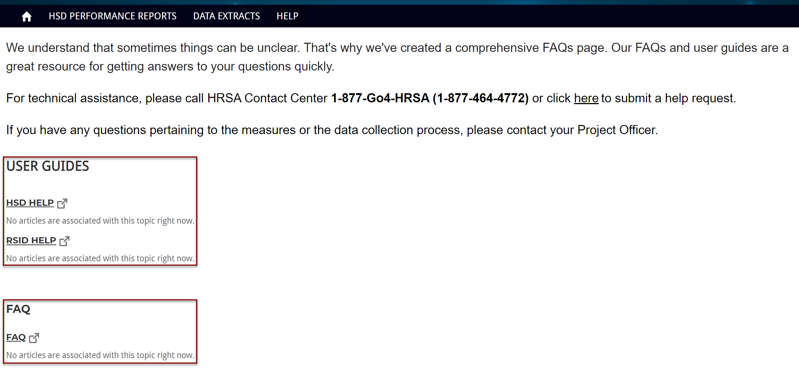

## General Information/Overview

This help page provides the Federal Office of Rural Health Policy (FORHP) grantees an overview of how to access and navigate through the HRSA Data Collection Platform, and specifically walks through the steps for Medicare Hospital Flexibility (**FLEX) grantees**. The help page includes how to navigate through the performance report (PIMS report), the steps to submit a report, and how to complete a change request from a Project Officer.

**IMPORTANT NOTE**: A few important notes while working on your Performance Report (PIMS Report):

* The system does **not auto-save** your work. Be sure to complete all required fields on a page and click the Next button to save the data.
* Multiple people can work on the Performance Report at the same time. However, **the person who makes the latest changes (when they click Next to save) will overwrite previous data**. To see the most recent data, navigate out of the report and open the report again.
* If you are **inactive for 15 minutes**, the system times out, and you will lose any unsaved data.
  + When you log back in, you may be directed to the last page you were working on instead of the homepage.
* You can identify required fields on the Performance Report by the **asterisk (*)** next to the field name.

## Accessing the HRSA Data Collection Platform

1. To access your Performance Report, login through <https://hrsa-dcpaas.my.site.com/pars> using the same Login.gov and 2-factor authentication used for the EHBs.

**Helpful Tip!** For additional information about creating a Login.gov account and signing in with 2-factor authentication, please visit the Login.gov help page: <https://help.hrsa.gov/x/8gESCw>.

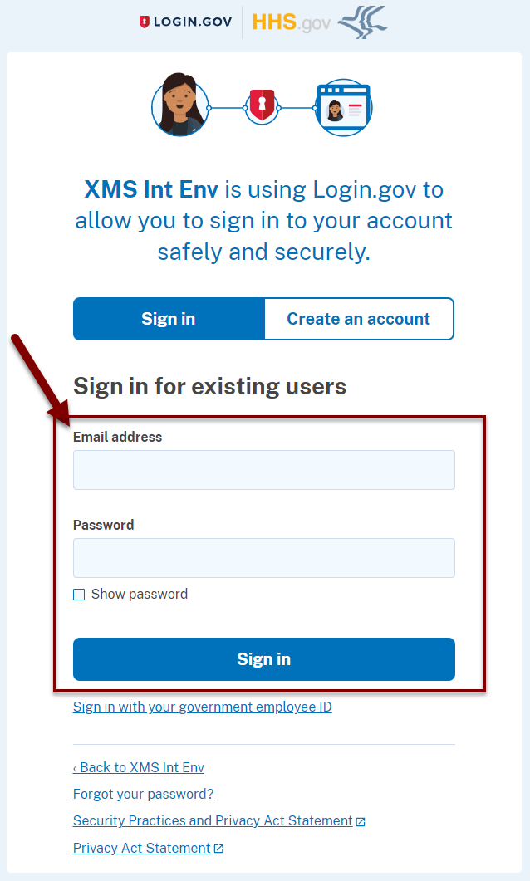

1. Review the U.S. Department of Health and Human Services Terms of Service and Privacy Policy statement and move the toggle button to **I Agree.**

Be sure to click **Next** to move to the next login page.

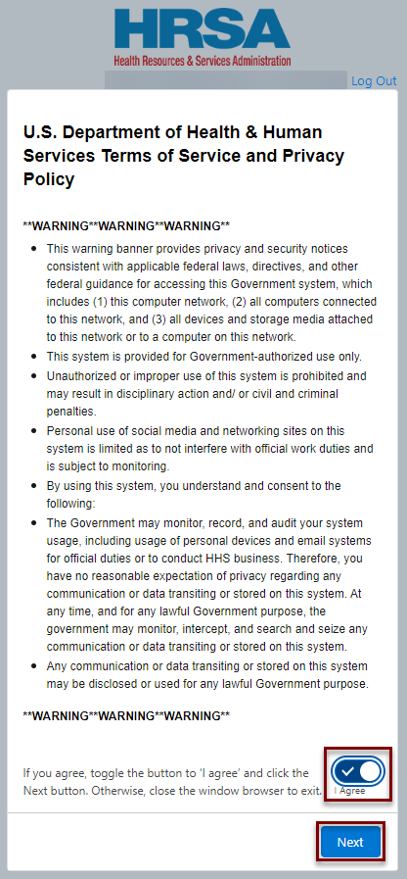

1. Select the **Finish** button to access the HRSA Data Collection Platform.

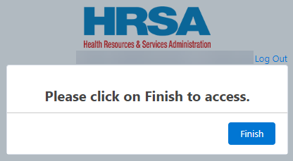

## HRSA Data Collection Platform Homepage Navigation

1. The HRSA Data Collection Platform home page provides background on the performance reports and access to your Performance Report (PIMS Report) and Other Reports.
2. Select your **name** on the top right side of the page to return to the home page or log out.
3. Click the **HSD** **Performance Reports** tab at the top of the page or the widget on the bottom of the page to access your Performance Report.
4. Click the **Data Extracts** tab at the top of the page or the widget on the bottom of the page to access Other Reports, such as the Grantee Raw Data Report.
5. Click the **Help** tab at the top of the page or the widget on the bottom of the page to view step-by-step instructions and FAQs.

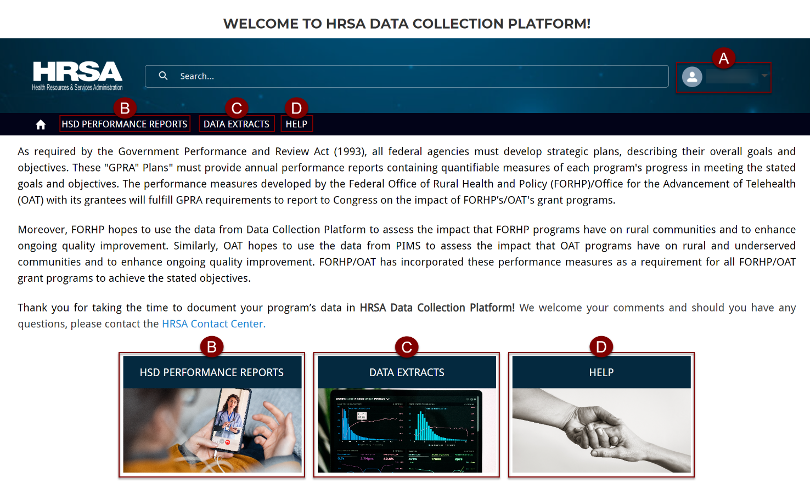

### Performance Report Filters

1. Select the **HSD** **Performance Reports** tab from the top navigation bar or widget to view a list of your Performance Reports. The page defaults to your Recently Viewed Performance Reports.
2. Click the **arrow** next to Recently Viewed to select a different List View: Approved Reports, Change Requested Reports, In Progress Reports, Recently Viewed, and Submitted Reports.
3. Click the **pin** next to the list view to set that list view as default.
4. Use the **Search** text box to narrow the results on the list page.

**Note:** Only the Tracking ID and Status are searchable.

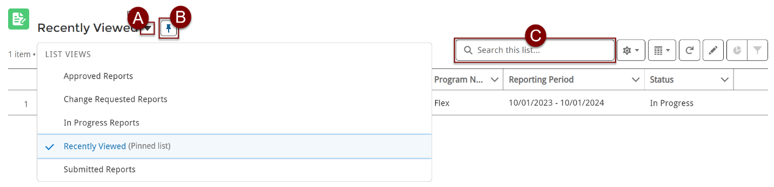

1. Each page displays the Tracking ID (autogenerated number from the system), Submission Status (if applicable to the page), Submission Name, Grant Number, Program Name, Reporting Period, and Status.
2. Click the **Tracking ID** to open the Performance Report.

**Note:** The Tracking ID is different than your grant number.

1. The **Status** column displays the status for the Performance Report as a whole.

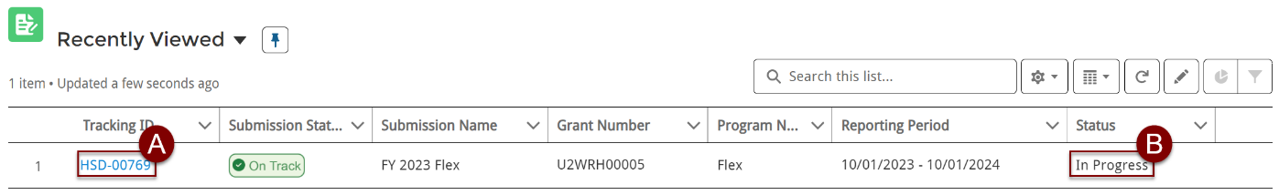

#### Approved Reports

1. The **Approved Reports** page lists Performance Reports in Approved status, after the HRSA Project Officer (PO) has reviewed and approved the Reports.

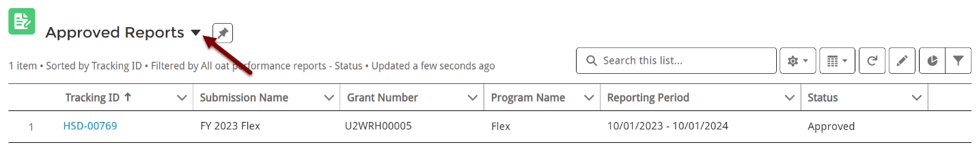

#### Change Requested Reports

1. The **Change Requested Reports** page lists Performance Reports in the Change Requested Status, after the HRSA PO has reviewed the reports and requested updates.

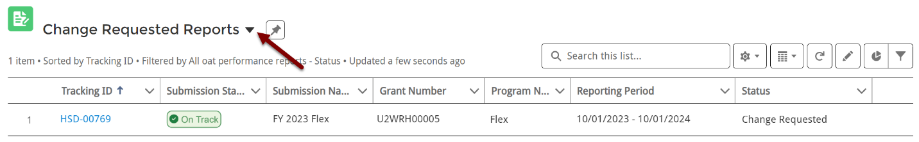

#### In Progress Reports

1. The **In Progress Reports** page lists Performance Reports that are in Not Started and In Progress statuses.

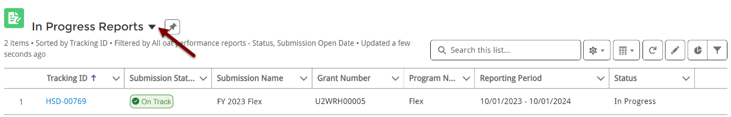

#### Recently Viewed

1. The **Recently Viewed** page allows you to easily return to Reports you recently opened.

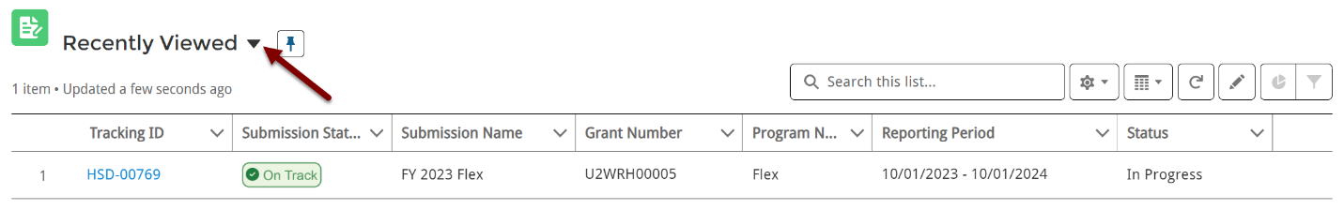

#### Submitted Reports

1. The **Submitted Reports** page lists Performance Reports in Submitted status. These are submitted to the PO, but the PO has not approved or requested changes. Once the PO makes a decision, the status updates to Approved or Change Requested.

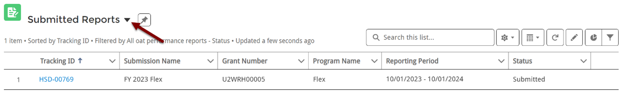

## Performance Reports

### Report Navigation

1. Click the **Tracking ID** to open the Performance Report.
2. The **Performance Report** page displays information about the Report and the status for each Form.
3. When you are ready to submit your Performance Report to the HRSA PO for review, click the **Submit for Review** button on the top right side of the page.
4. Expand the **header** to view the Grant Number, Grantee, Review Status, Current Reporting period, Report Due Date, and Submitted Date.
5. The **Grant Details** header displays the Grant Number, Grantee Name, and Current Reporting Period.
6. The **Grantee Data Entry** section lists the forms to complete within the Performance Report.
7. The **Approval History** section displays details when the grantee submits their report.

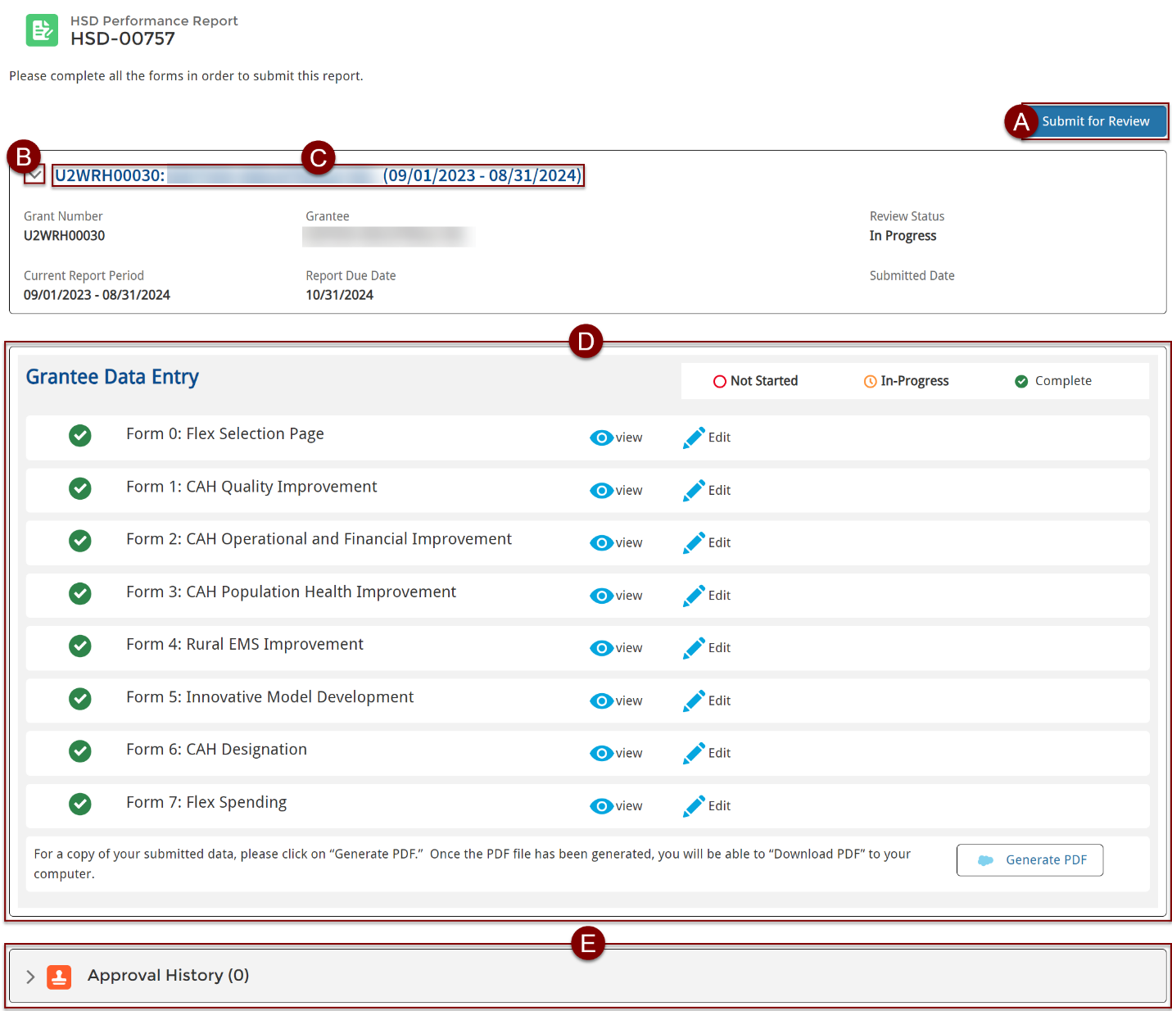

1. The **Grantee Data Entry** section provides information about the Performance Report forms.

**Note:** The number of forms varies based on data entered for your organization.

1. The icons represent the different status types of the forms: Not Started forms have a red circle, In-Progress forms have a yellow clock, and Completed forms have a green circle with a checkmark.
2. The **Form status** is displayed to the left of the name: Not Started, In Progress, and Complete. These automatically update as you work on the form.

**Note:** If you are unable to see the Status for a Form, refresh your page or return to the HSD Performance Report page and reopen the report.

1. Select **View** to open a read-only version of the form.
2. Select **Start** (if the form is in Not Started status) or **Edit** (if the form is in In Progress status) to work on the form.

**Note:** You cannot edit forms after submitting the report to the HRSA PO for review.

1. Select the **Generate PDF** button to view the Performance Report in PDF format or download the PDF.

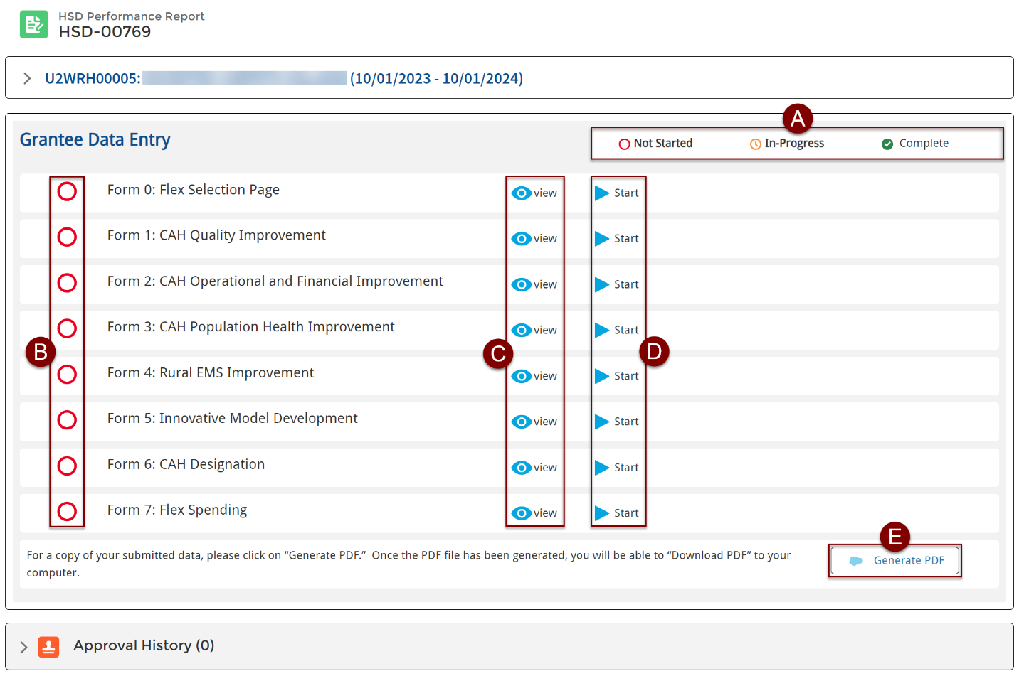

### Complete FLEX Forms

1. Click **Start** (if the form is in Not Started status) or **Edit** (if the form is in In Progress status) to begin working on the form.

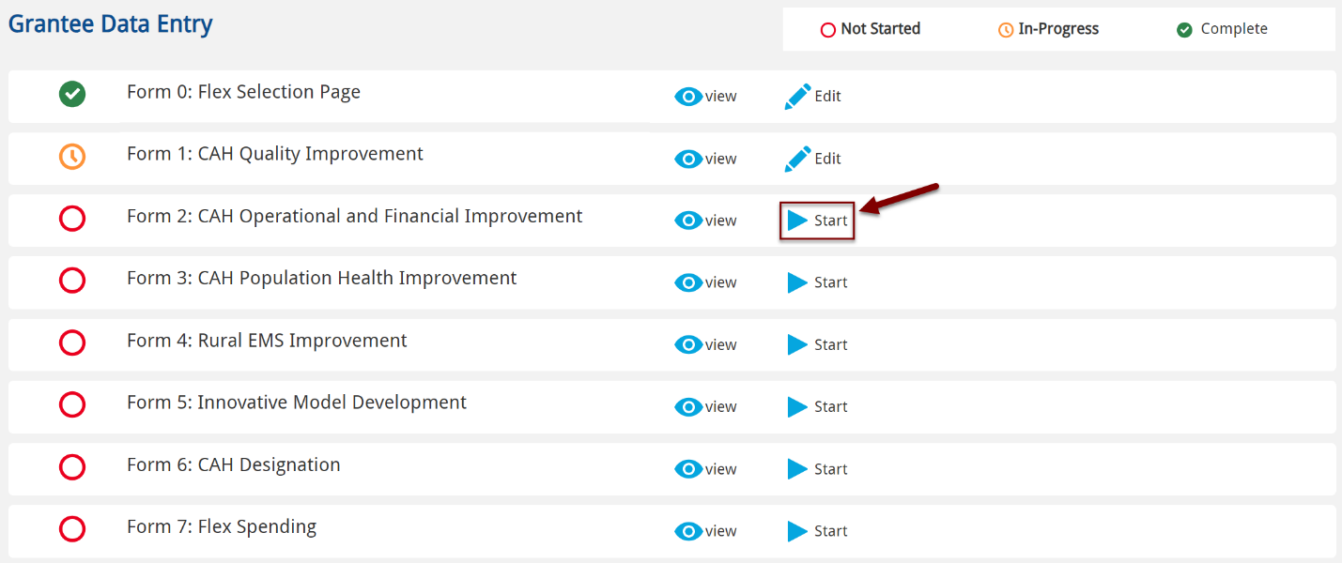

1. To navigate through the form:
2. Select the **Back to Main Screen** button to return to the Performance Report page.
3. After reading and completing the information on the page, select **Next** to continue to the next step of the form.

**Important Note:** **The system does** **not auto-save,** so you must complete all required fields and click **Next** to save the data. If you select Back to Main Screen without saving first, you may lose your data.

1. Track your progress on the form using the **Steps** on the right side of the page. Return to previous steps by selecting the step.

**Helpful Tip:** Once completed, the step has a green checkmark on the progress bar.

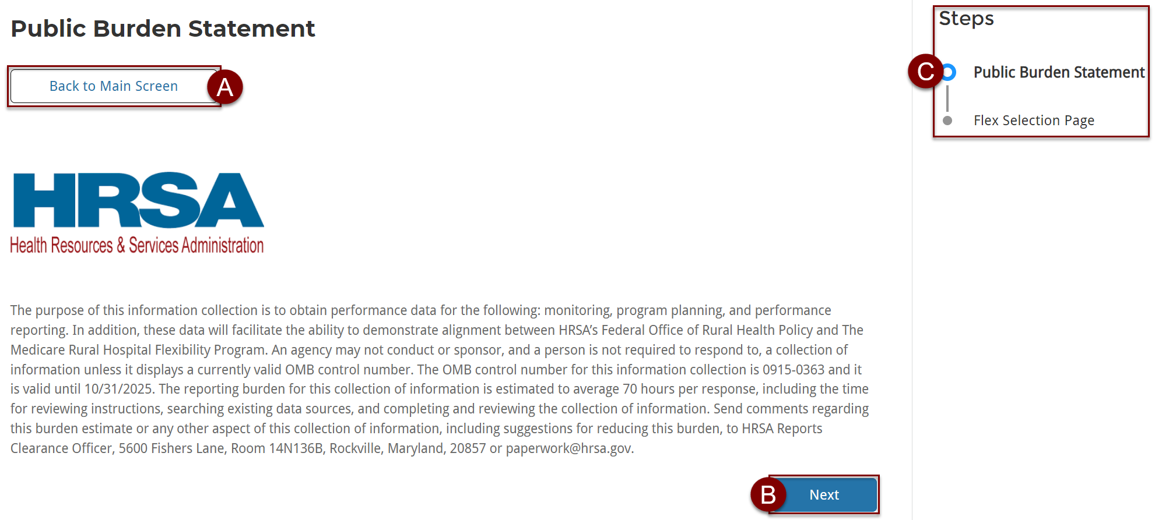

1. Review the Public Burden Statement and click **Next** to continue through the form.

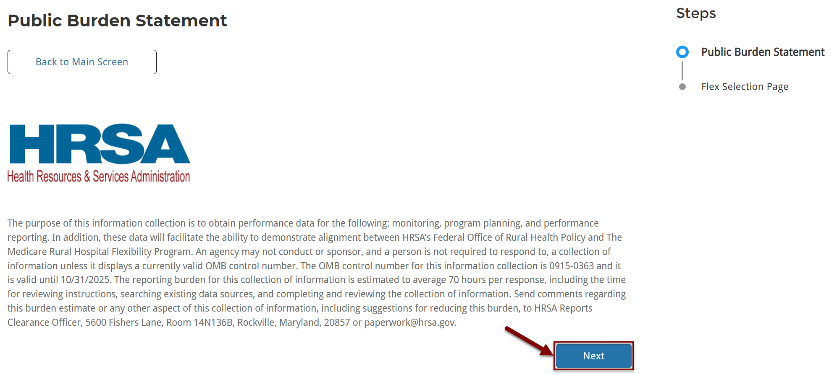

1. The top of the Performance Report page displays the form number and section name.
2. Expand the **arrow** next to the header to view details about the grant and report status.
3. Complete **all** **required fields**, as indicated with an asterisk (*).
4. If a required field is left blank or has an incorrect data type, an **error message** generates with information to correct the data.

**Important Notes:**

* The system does **not auto-save your work**. Be sure to complete all required fields on a page and click the **Next** button to save the data.
* Multiple people can work on the Performance Report at the same time. However, **the person who makes the latest changes (when they click Next to save) will overwrite previous data.** To see the most recent data, navigate out of the report and open the report again.
* If you are **inactive for 15 minutes**, the system times out, and you will lose any unsaved data.
* When you log back in, you may be directed to the last page you were working on instead of the homepage.
* You can identify required fields on the Performance Report by the **asterisk (*)** next to the field name.

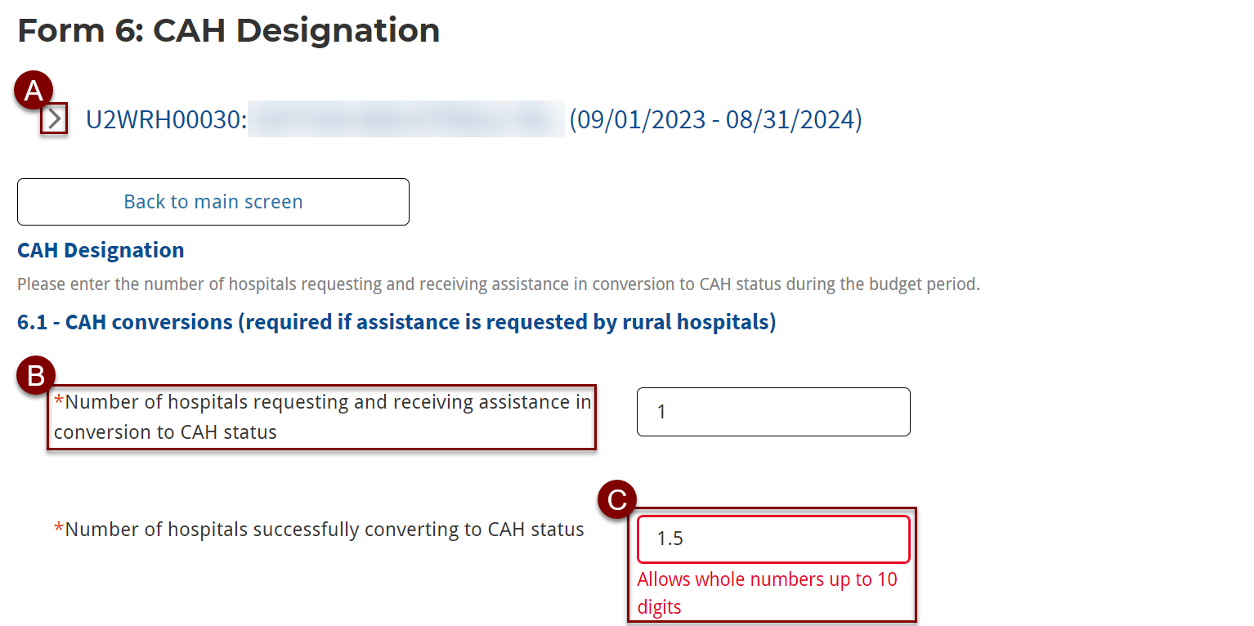

1. At the bottom of each form page, you can add **optional** comments and attachments.
2. Use the **Comments** section to include additional information about the data or notes for the HRSA PO reviewing the report. This is optional.

**Note:** The Comments display on each step of the form and are visible when you submit the Performance Report for approval.

1. Select **Upload Files** in the File Attachments section to include any files for the report. This is optional.

**Note:** Files are displayed on each step of the form and included when the Performance Report is sent to HRSA for approval. File Attachments are not included in generated PDFs.

1. To return to the previous step, select **Previous** at the bottom of the page.

**Important Note:** If you select **Previous**, you will lose the data entered on that page. The system does not autosave, so you must complete all required fields and click **Next** to save the data.

1. After completing all required fields, select **Next** to continue to the next step on the form and save your work.

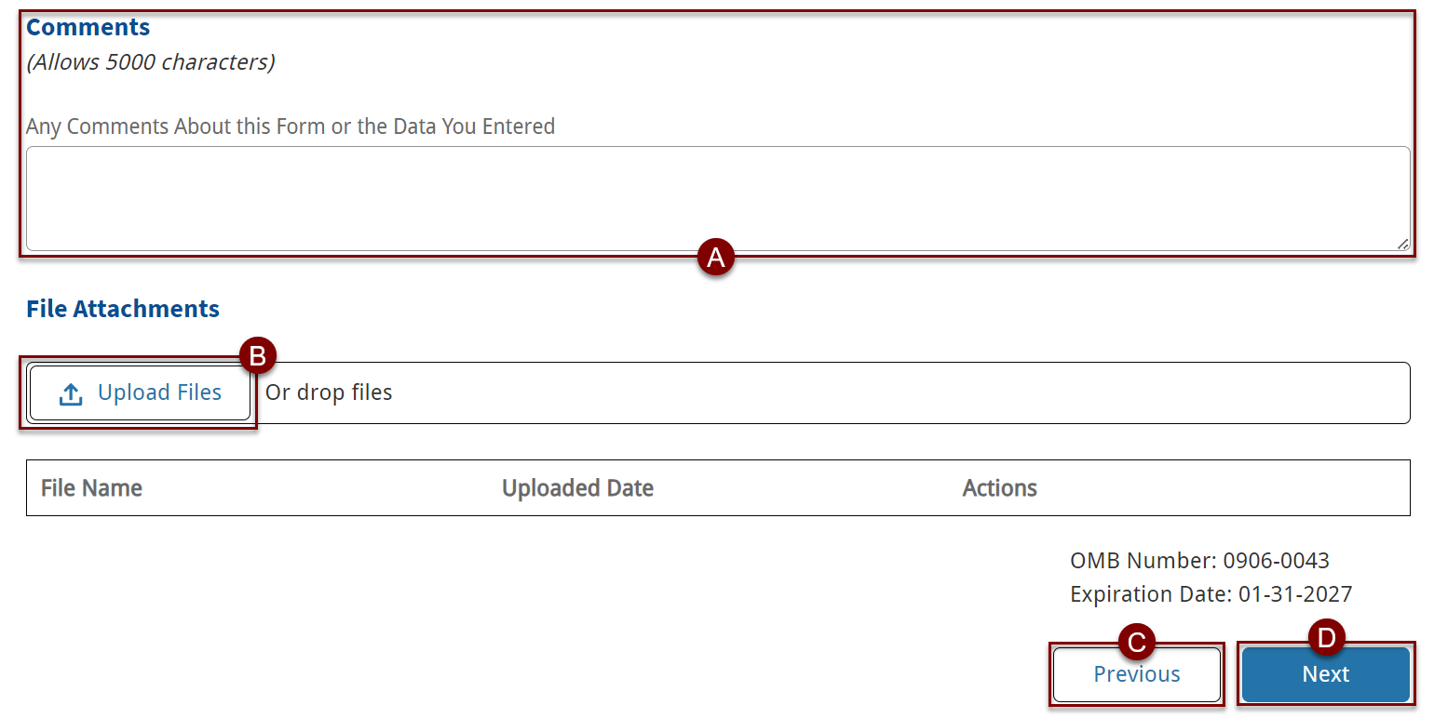

1. Continue through each step until the form is complete. Additional Comments and Files for each step are included with the Performance Report when submitted for approval.

#### Example Questions from Forms 0, 1, & 7

1. On Form 0, select applicable optional options.

**Note:** selections made affect later forms.

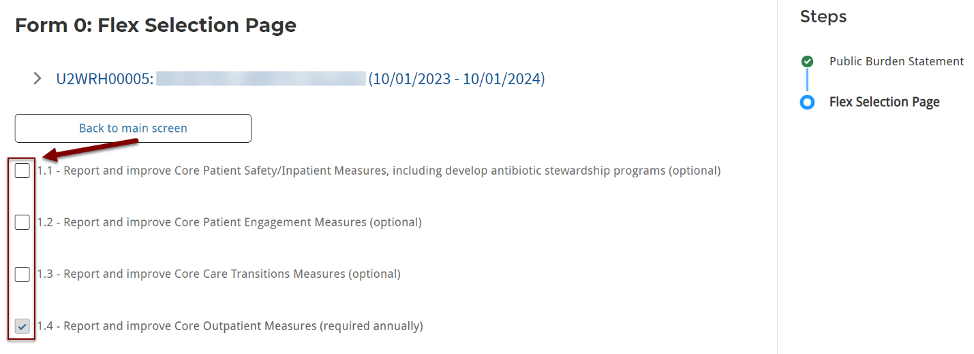

1. On Form 1, in the Core MBQIP Measures section, select CAHs that participated and improved in each MBQIP activity category.
2. Click the box(es) in the **Select All** row to select all activity categories.
3. The activity category must be selected in the **Participation** column to select it in the **Improvement** column.
4. The **Total** row auto-calculates based on the selections.
5. Once all selections have been made, click **Save** before clicking **Next**.

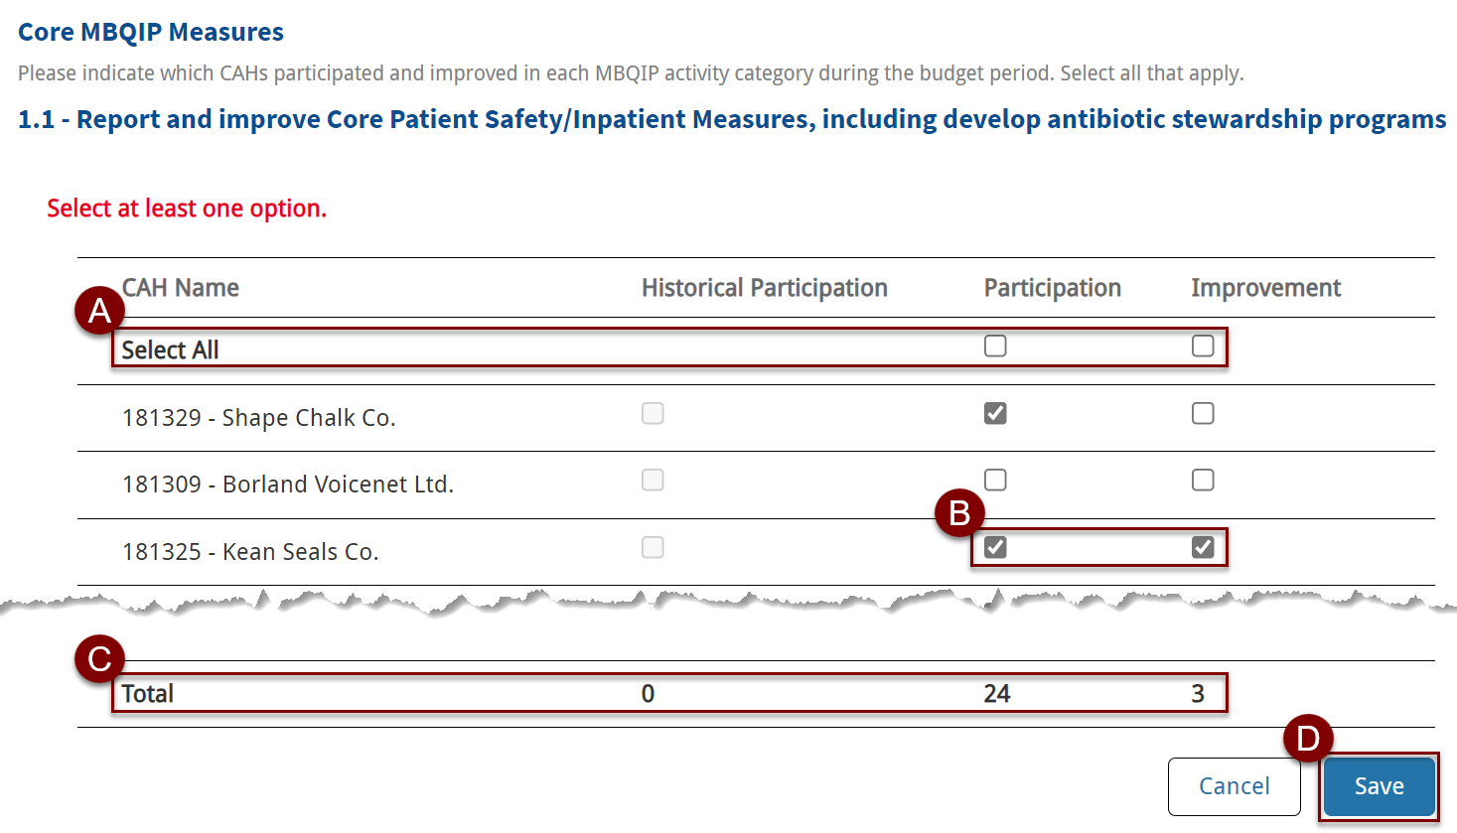

1. On Form 7, complete all required fields in the Spending Summary section. The **Actual Program Spending for Current Report Period** calculation auto-populates based on the information entered above.

**Note:** The **Total Flex Funds Utilized** calculation on Page 6 MUST match this calculation. However, this calculation is only available for reference on Page 1 of Form 7.

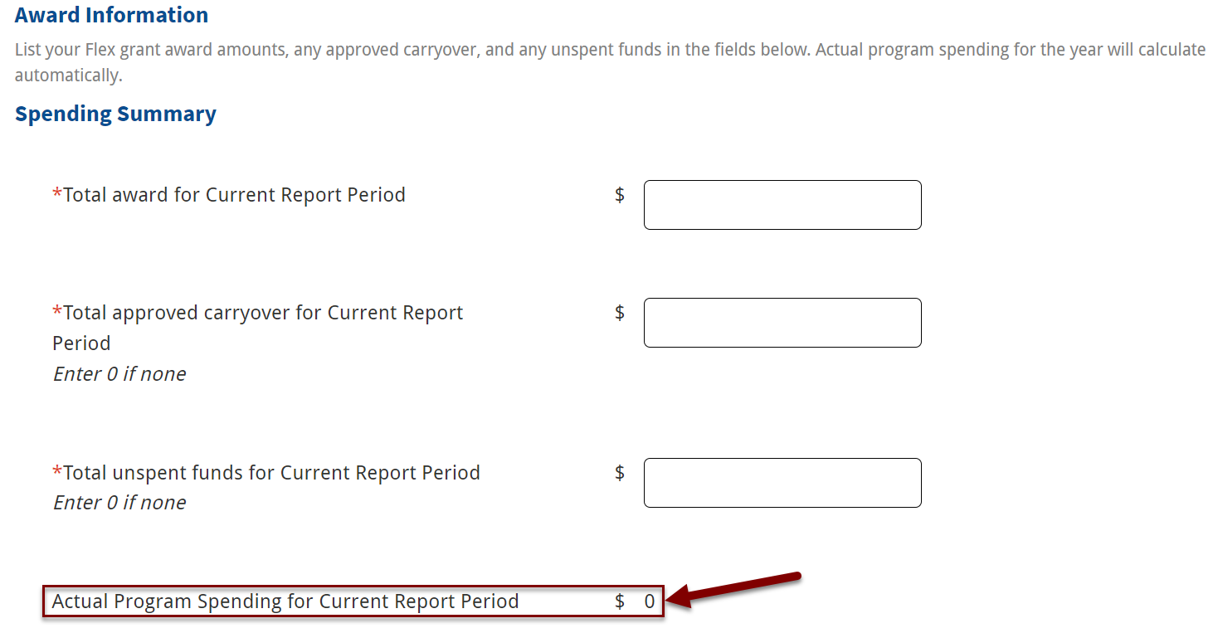

### Submit for Review

1. Once all required fields on the form are complete, the form status updates to **Complete**. Be sure to complete all forms within the Performance Report.

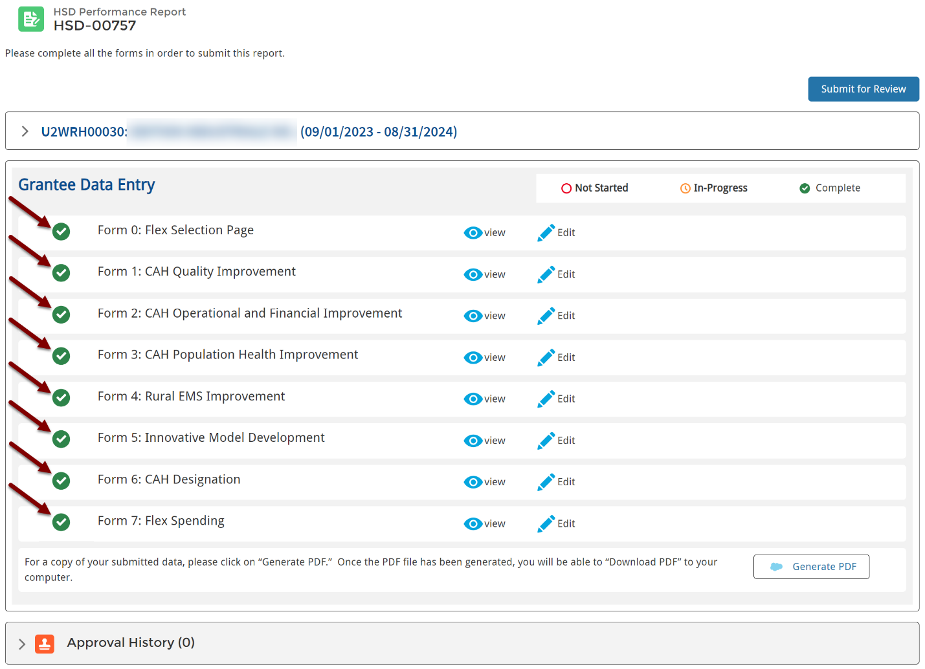

1. When you are ready to submit the Performance Report to the HRSA PO for review, select the **Submit for Review** button.

**Note:** The Performance Report status remains In Progress until the Performance Report is submitted for approval.

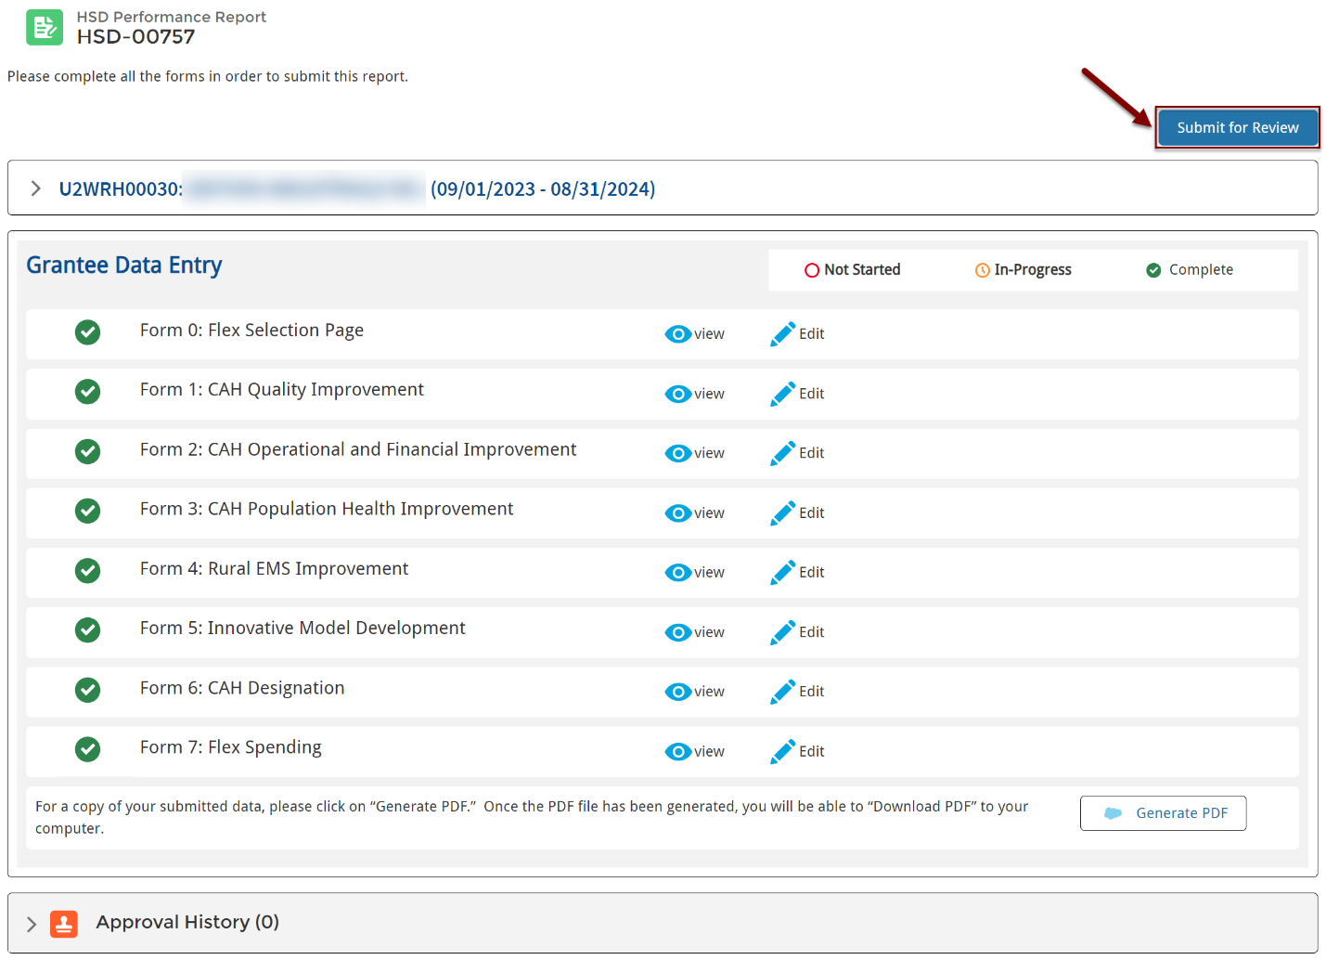

1. Enter comments for the PO (optional) and click **Submit** to send the Performance Report to your HRSA PO.

**Important Note:** Once you submit the report you can open a read-only view but cannot make additional edits unless the PO requests changes. If you click the Submit for Review button after the report is submitted or approved, you will receive an error message.

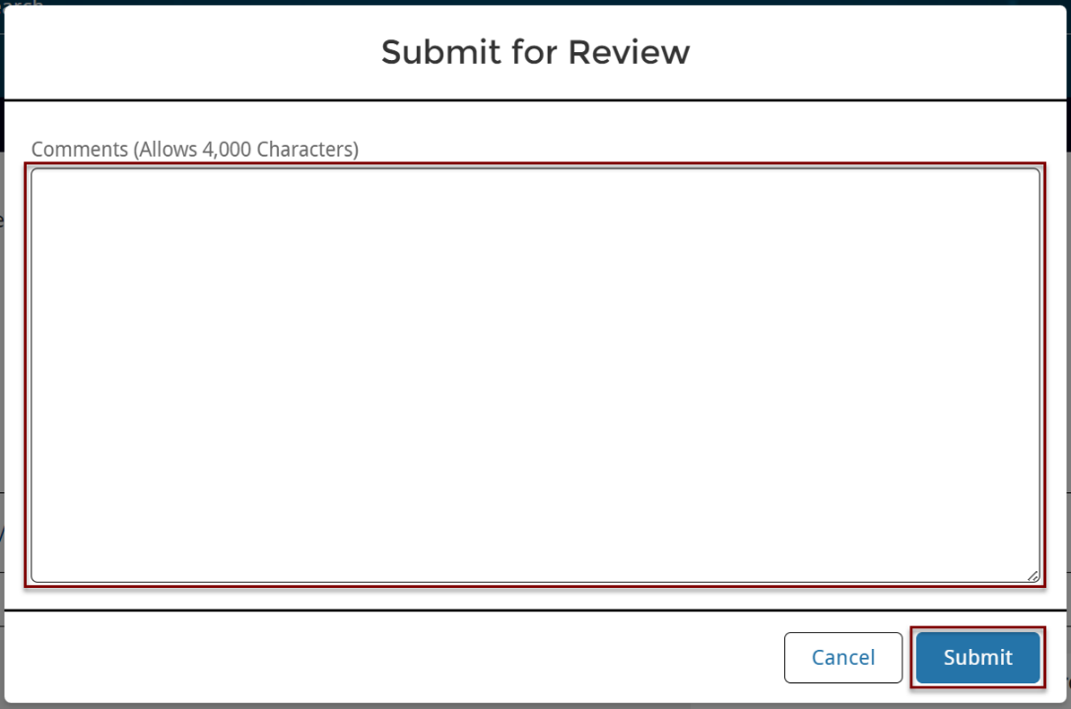

1. After submitting the Performance Report for approval, the Performance Report status updates to **Submitted** and is available on the Submitted Reports list page.

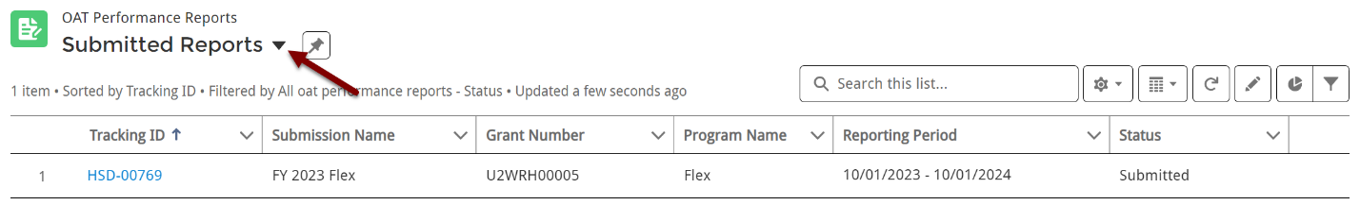

1. You can track the approval status through the **Approval History** section on the Performance Report page.

Click the arrow on the right side of the Approval History section to view full comments.

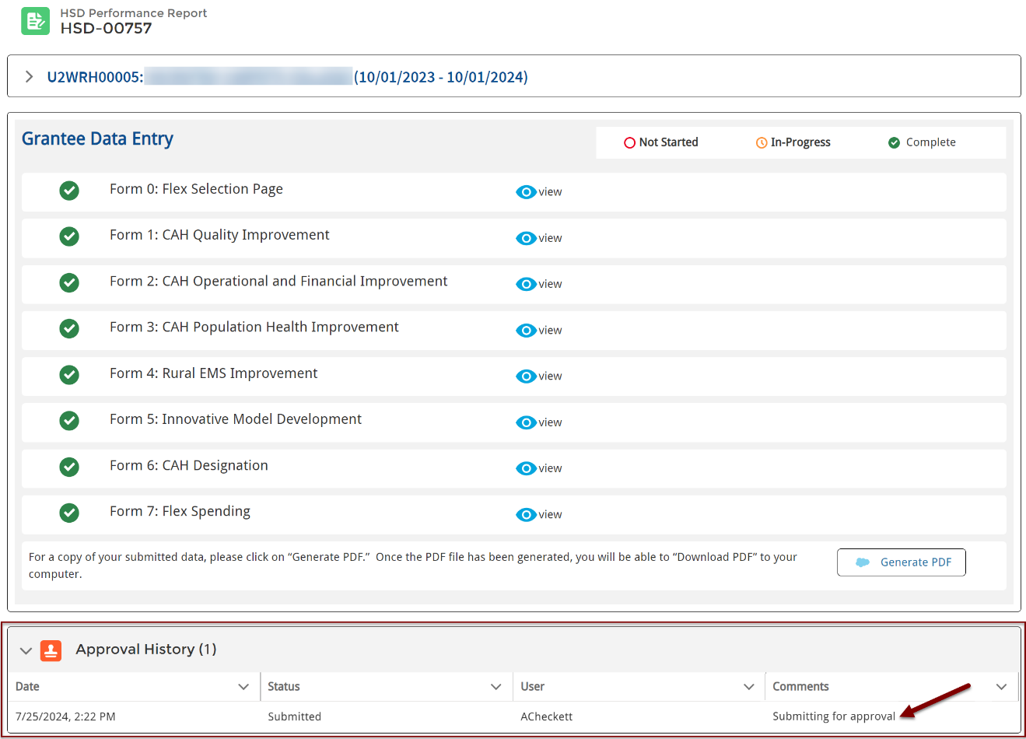

1. After the HRSA PO approves the Performance Report, it is listed on the Approved Reports list page and the status updates to **Approved**.

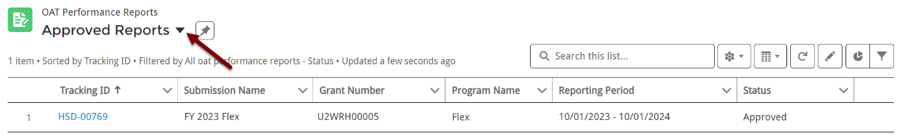

## 

## Generate PDF

1. You have the option to Generate a PDF copy for the report at any time.

Click **Generate PDF** on the bottom right side of the Performance Report page.

**NOTE**: The process may take a moment after you click the Generate PDF button.

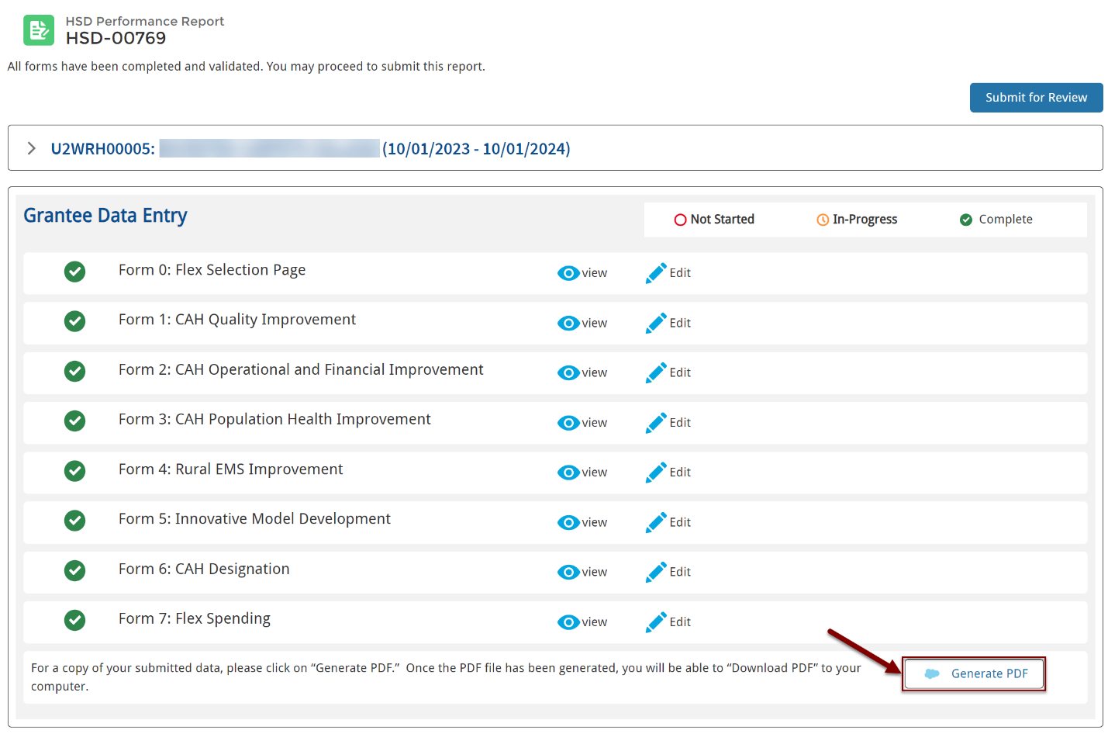

1. You can review the report through the preview or select the **Download PDF** button to download a copy of the report.

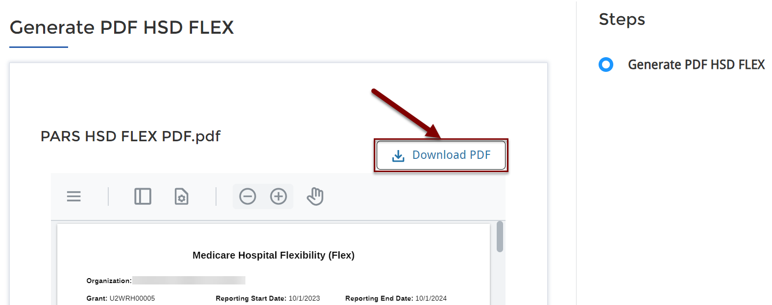

## Change Requests

1. The HRSA Project Officer can request changes to the Performance Report after they review. You will receive an email notification of the change request with comments from the HRSA Project Officer.

The Performance Report moves to the Change Requested Reports list page and the status updates to **Change Requested**.

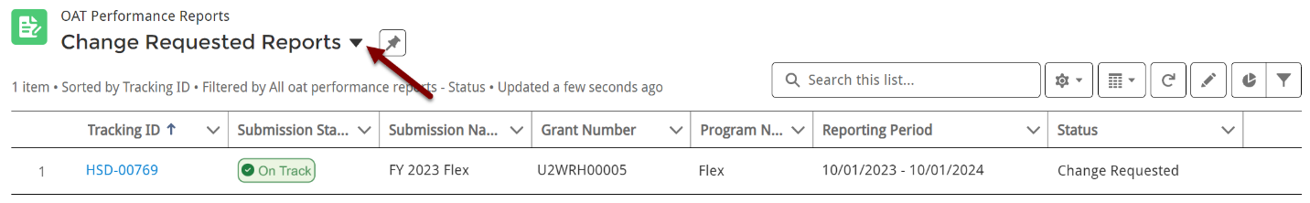

Select the **Tracking ID** to open the Performance Report and review comments from the PO in the Approval History section. After making updates, be sure to click **Submit for Review** for the PO to review again.

1. The Approval History section displays the HRSA PO’s comments related to the change request.

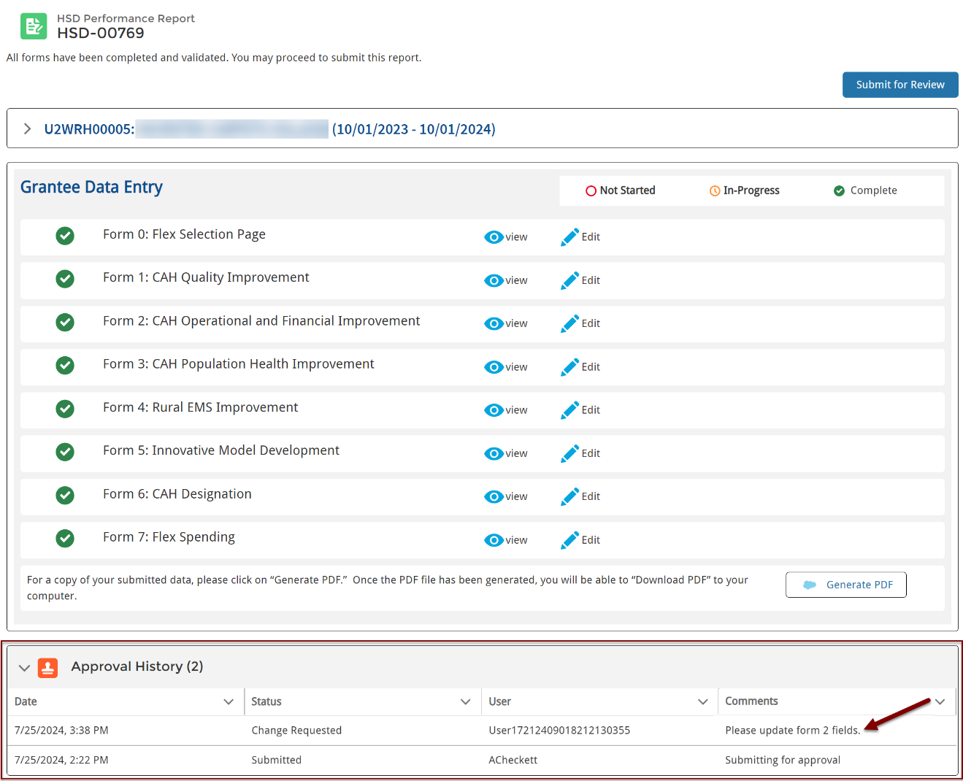

## Grantee Raw Data Report

1. To view reports, including the Grantee Raw Data Report, select **Data Extracts** from the top navigation bar.



1. Use the left navigation bar to view Reports, Folders, and Favorites.
2. Select **All Reports** the first time you open the Data Extracts section to view the Grantee Raw Data Report.
3. Click the **report name** to open the Grantee Raw Data Report.
4. Click the **folder name** to view the folder with the report.
5. Select the **arrow** on the right side of the page to **Run** the report, **Export** the report to download a file, or mark the report as a **Favorite.**

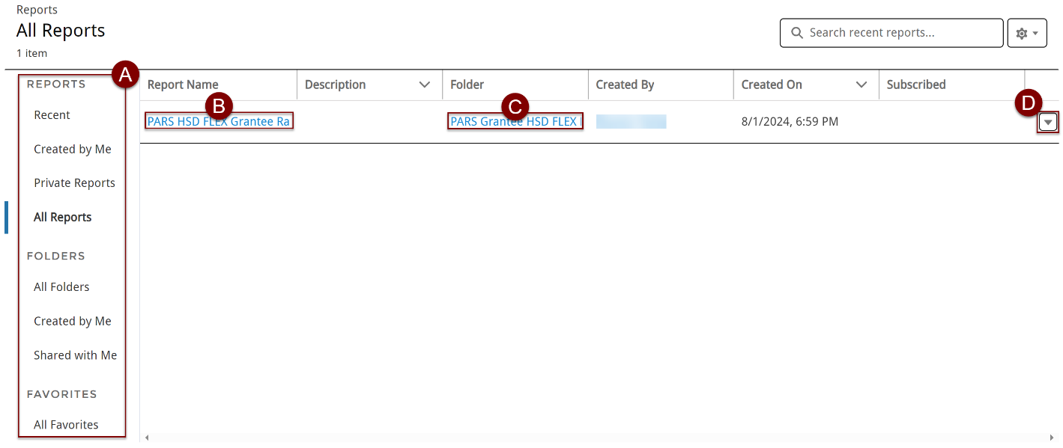

1. Click on the **Report Name** to open the **Grantee Raw Data Report**.

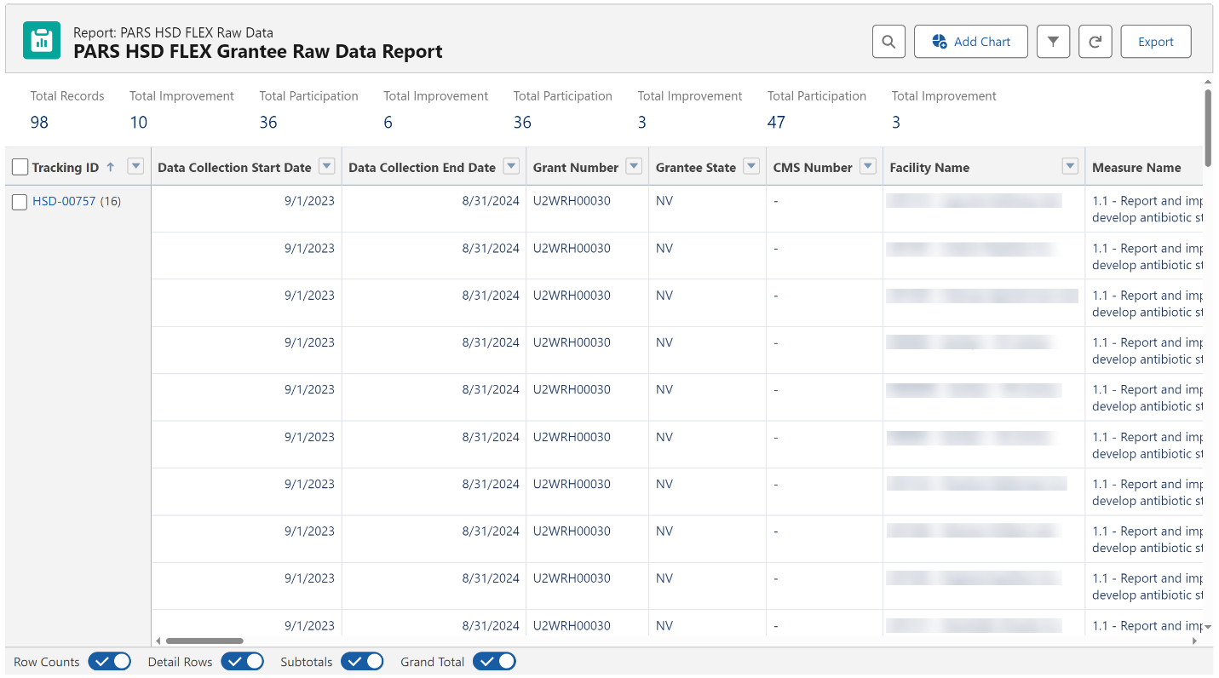

1. Click on **Export** from the report drop-down menu on the Reports page or the top right side of the report to export the report. Select **Formatted Report** to export the report, as it formatted on your screen, to an Excel spreadsheet and click the **Export** button.

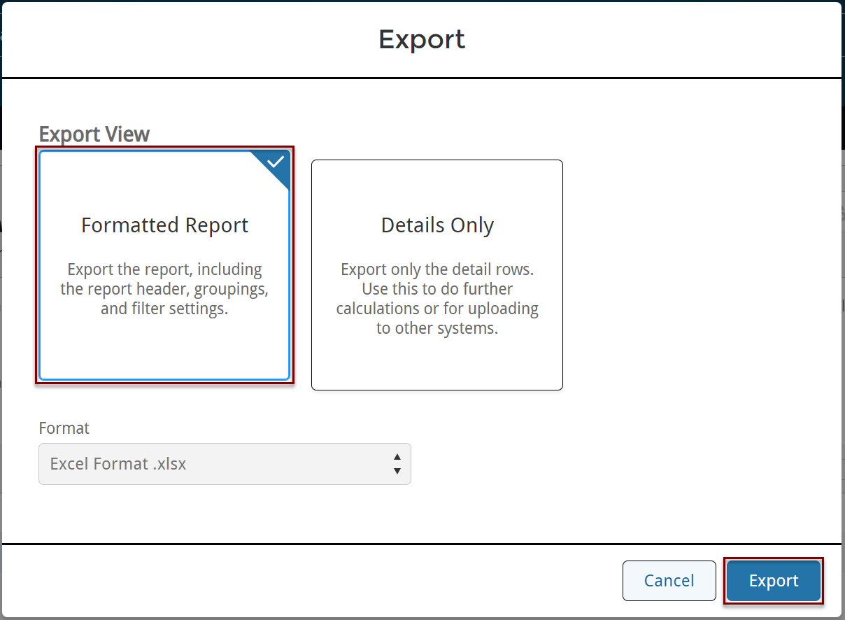

1. Click on **Export** from the report drop-down menu on the Reports page or the top right side of the report to export the report. Select **Details Only**, choose a format from the drop-down menus, and click the **Export** button.

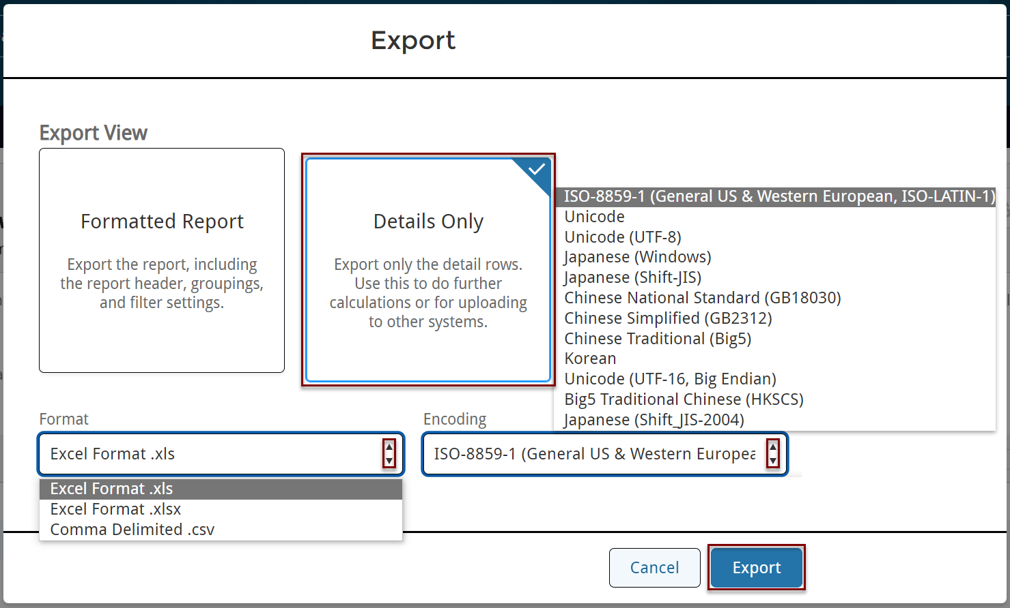

Definitions for FY 2023 Reporting

**Budget year FY 2023** refers to Flex activities conducted from 9/1/2023 through 8/31/2024.

**Participation** answers the question, “Did this CAH engage in a Flex-funded activity intended to improve a specific outcome during the past budget year?”

To be considered participating in PIMS, CAHs must be engaged in a project or activity that meets the following criteria:

* Occurred between 9/1/2023 and 8/31/2024
* Used Flex funding
* Had a defined goal or improvement outcome
* Activities of the project were beyond normal Flex engagement

In most cases, you will only report participation for a subset of CAHs in your state. Some activity categories in the work plan may have no in-depth CAH engagements that meet the PIMS participation criteria.

You will report for all CAHs that were open during the budget year, even those that closed or converted during the reporting period.

You should not report a CAH as participating if it:

* Started an activity but quickly dropped out or failed to substantially engage in the activity.
* Is only participating in other performance improvement projects not supported by Flex resources (e.g., HIIN projects).

**Table of examples of activities that meet and do not meet the criteria for participation:**

|  |  |
| --- | --- |
| **Meet PIMS participation criteria** | **Do NOT meet PIMS participation criteria** |
| Working towards a goal to improve MBQIP reporting | Reporting in MBQIP alone |
| Coordinating a chargemaster review | Projects that CAHs started but quickly ended or failed to engage in |
| Attending a two-day TeamSTEPPS training | Attending a state rural health conference |
| Joining a HCAHPS quality improvement cohort that meets bi-monthly via webinar | Participating in one webinar on a specific quality improvement topic |

**Improvement** answers the question, “Did the participating CAH improve the outcome that was the target of the activity?”

* Improvement is any change in the positive direction, including Sustained High Performance.
* You can only report improvement for CAHs that are also participating in the activity.
* CAHs listed in the Historical Participation column can be selected for improvement without selecting participation for the current year as long as the identified improvement occurred in or immediately after the current FY.
* If a CAH is participating in multiple projects within a PIMS activity, they need only show improvement in one of the target outcomes to qualify for improvement.
* If you have no information on improvement or the data is not yet available, leave the check box blank which indicates “no [identified] improvement”.

The [PIMS Data Collection Tool](https://www.ruralcenter.org/resource-library/pims-data-collection-tool) offers a format for Flex Coordinators to track CAHs throughout the year as they engage in Flex-funded improvement activities and identify individual improvement goals.

**Sustained high performance** only applies to quality improvement, Program Area 1. This concept recognizes that state Flex programs use considerable resources helping CAHs maintain a high level of performance after they initially reach that level. *This is a very high level of performance, and we expect few CAHs to meet the applicable benchmarks.* We added this reporting definition in FY 2016 in response to Flex Coordinator concerns that improvement, as defined for PIMS, excluded CAHs that consistently maintained excellent performance since most quality metrics have an upper limit.

* Applies to CAHs participating in one or more Flex-funded activities in categories 1.1 through 1.8.
* Only applies to CAHs that do not have reportable improvement activities in the applicable Flex activity category—sustained high performance requires that they were already performing at the top level at the beginning of the year.
* For this section, *high performance* refers to actual scores, e.g. percentage of EDTC cases with all data elements, while *measure reporting* refers to the reporting of data, or zero cases, regardless of scores.
* A CAH must achieve one of the following for the most recently available four quarters of MBQIP data (or year in the case of annual measures):
  + For all MBQIP measures except HCAHPS a CAH must maintain *high performance* at or above the 90th percentile for CAHs nationally on the applicable measure(s) every quarter.
  + For HCAHPS *high performance* a CAH must meet or exceed the CMS Value-Based Purchasing (VBP) Program performance benchmark for the performance period that most closely aligns with the CAH’s HCAHPS data. Note that payment periods are two years after the performance period so use the appropriate performance period, not the payment adjustment period. VBP benchmark scores are available from the [Quality Reporting Center Inpatient Resources page](https://www.qualityreportingcenter.com/inpatient/iqr/resources-and-tools/) (section called Domain Weighting in VBP Resources). The VBP performance standard defines a floor, a threshold, and a benchmark—the highest level, the benchmark, is based on the top decile of national performance.
  + For EDTC and HCAHPS, CAHs must meet the performance benchmarks for all sub-measures.
  + Sustained high performance in *measure reporting* requires the CAH to report qualifying data or zero cases for all four quarters for all core measures and sub-measures in the applicable MBQIP domain.
  + HCAHPS reporting is not eligible for sustained high performance for *measure reporting* since CAHs need less Flex program assistance with the process of HCAHPS reporting after establishing vendor contracts.
  + Annually reported measures are not eligible for sustained high performance for *measure reporting* since one data point cannot demonstrate a trend.
* Flex Coordinators that use the improvement box to indicate CAHs that demonstrated sustained high performance must list those CAHs in the comment box at the bottom of the quality improvement reporting page. Based on Flex Coordinator input, we expect that this will be a small number of CAHs, but the comments will show how often Flex Coordinators identify sustained high performance. The comment should include the following information:
  + Activity category (e.g. 1.3), CAH name and Medicare number (CCN), reason *(high performance* or *measure reporting*)
* CAHs must be participating in Flex funded activities in the applicable activity category to be reported for sustained high performance. A CAH that achieves sustained high performance without in-depth engagement(s) with the state Flex program should not be reported in PIMS which is limited to reporting on Flex-funded activities and interventions.
* We anticipate that consistent reporting of existing MBQIP measures will not be considered high performance in PIMS after the end of the current Flex Program performance period and sustained high performance will be limited to performance scores and reporting of new measures.

Appendix C: Flex FY 2022 Awards

|  |  |  |  |
| --- | --- | --- | --- |
| **State** | **Organization** | **Cooperative Agreement Number** | **Award Amount** |
| AK | HEALTH AND SOCIAL SERVICES, ALASKA DEPARTMENT OF | U2WRH33307 | $703,943.00 |
| AL | PUBLIC HEALTH, ALABAMA DEPARTMENT OF | U2WRH33293 | $419,493.00 |
| AR | ARKANSAS DEPARTMENT OF HEALTH | U2WRH33304 | $693,463.00 |
| AZ | University Of Arizona | U2WRH33311 | $635,484.00 |
| CA | California Department of Health Care Access & Information | U2WRH45477 | $624,429.00 |
| CO | COLORADO RURAL HEALTH CENTER | U2WRH33305 | $754,567.00 |
| FL | Health, Florida Department of | U2WRH33316 | $588,658.00 |
| GA | COMMUNITY HEALTH, GEORGIA DEPT OF | U2WRH33286 | $749,985.00 |
| HI | HEALTH, HAWAII DEPARTMENT OF | U2WRH33309 | $513,575.00 |
| IA | PUBLIC HEALTH, IOWA DEPARTMENT OF | U2WRH33302 | $871,770.00 |
| ID | HEALTH AND WELFARE, IDAHO DEPARTMENT OF | U2WRH33308 | $738,400.00 |
| IL | Public Health, Illinois Department Of | U2WRH33301 | $949,120.00 |
| IN | Indiana State Department Of Health | U2WRH33300 | $756,210.00 |
| KS | HEALTH AND ENVIRONMENT, KANSAS DEPARTMENT OF | U2WRH33306 | $1,115,417.00 |
| KY | University Of Kentucky | U2WRH33312 | $693,629.00 |
| LA | Health, Louisiana Department Of | U2WRH33310 | $649,128.00 |
| MA | PUBLIC HEALTH, MASSACHUSETTS DEPT OF | U2WRH33294 | $364,663.00 |
| ME | HEALTH AND HUMAN SERVICES, MAINE DEPARTMENT OF | U2WRH33288 | $504,176.00 |
| MI | Michigan Center For Rural Health | U2WRH33317 | $797,231.00 |
| MN | DEPARTMENT OF HEALTH MINNESOTA | U2WRH33314 | $1,049,465.00 |
| MO | HEALTH AND SENIOR SERVICES, MISSOURI DEPARTMENT OF | U2WRH33295 | $587,662.00 |
| MS | HEALTH, MISSISSIPPI STATE DEPARTMENT OF | U2WRH33290 | $562,068.00 |
| MT | PUBLIC HEALTH AND HUMAN SERVICES, MONTANA DEPARTMENT OF | U2WRH33320 | $928,510.00 |
| NC | Health & Human Services, North Carolina Department Of | U2WRH33287 | $720,993.00 |
| ND | University Of North Dakota | U2WRH33321 | $939,181.00 |
| NE | HEALTH AND HUMAN SERVICES, NEBRASKA DEPARTMENT OF | U2WRH33315 | $1,016,212.00 |
| NH | HEALTH AND HUMAN SERVICES, NEW HAMPSHIRE DEPT OF | U2WRH33289 | $496,871.00 |
| NM | HEALTH, NEW MEXICO DEPARTMENT OF | U2WRH33297 | $365,754.00 |
| NV | Nevada System of Higher Education | U2WRH33318 | $570,028.00 |
| NY | HEALTH RESEARCH, INC. | U2WRH33296 | $454,693.00 |
| OH | Health, Ohio Department of | U2WRH33298 | $792,447.00 |
| OK | OKLAHOMA STATE UNIVERSITY | U2WRH33319 | $775,410.00 |
| OR | Oregon Health & Science University | U2WRH33327 | $803,488.00 |
| PA | Pennsylvania State University, The | U2WRH33292 | $511,780.00 |
| SC | South Carolina Office of Rural Health | U2WRH33328 | $454,147.00 |
| SD | South Dakota Department of Health | U2WRH33329 | $775,690.00 |
| TN | Health, Tennessee Dept Of | U2WRH33325 | $573,873.00 |
| TX | AGRICULTURE, TEXAS DEPARTMENT OF | U2WRH33313 | $1,037,942.00 |
| UT | DEPARTMENT OF HEALTH UTAH | U2WRH33323 | $450,611.00 |
| VA | HEALTH, VIRGINIA DEPARTMENT OF | U2WRH33299 | $410,691.00 |
| VT | Human Services, Vermont Agency Of | U2WRH33291 | $368,660.00 |
| WA | HEALTH, WASHINGTON STATE DEPARTMENT OF | U2WRH33326 | $790,530.00 |
| WI | UNIVERSITY OF WISCONSIN SYSTEM | U2WRH33303 | $926,665.00 |
| WV | Health And Human Resources, West Virginia Department Of | U2WRH33324 | $634,631.00 |
| WY | WYOMING, DEPARTMENT OF HEALTH | U2WRH33330 | $572,666.00 |
| 45 | Totals |  | $30,694,009 |

We expect that the “Total award for Current Report Period” on the Flex Spending page will reflect these award amounts. Please use the comment box to explain any discrepancies.