|  |  |  |  |
| --- | --- | --- | --- |
| **SHIP Grant FY** |  | **Funding Amount** |  |
| **Contributing Hospital** | ABC County Hospital | **Contact Person** | Jane Doe |
|  | ABC Regional Health Center |  |  |
|  |  |  |  |
| **Selected Category** | PB or PPS Investment Activities | | |

**Shared/Consortium/Network Hospital SHIP Funds**

**Network Decision Tree**

Per conversations with the above two hospitals, request was for Crisis Prevention Intervention training for the network to affordably participate in training. After multiple calls with EMR Vendor contact and Jane Doe ABC Education, it was determined that yes this would be a feasible project and in great demand as noted by more than 50% of Chief Nurses requesting participation and/or need within their facility. EMR Vendor demonstrates an ROI for healthcare as follows:

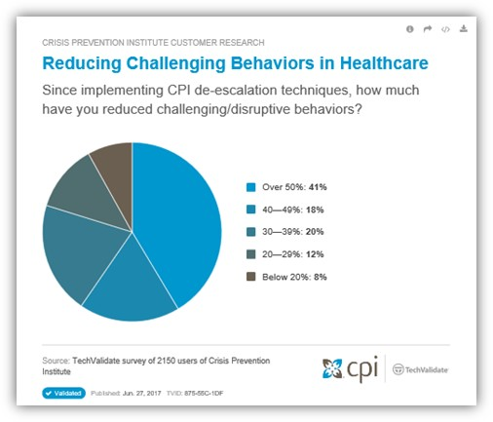

Per conversation with John Doe, ABC Institute is allowing an exception for our network to provide up-to 5 regional trainers to support our CAHs and small, rural hospitals in providing ongoing training within their hospitals. This allows our hospitals to provide training without the large overhead costs of supporting an on-site master trainer.

The tentative plan is to host a ABC training event in ABC Town in September at the new office site and allow other participants to join at this time. Funding will be allocated to ICAHN staff and members for participation in training and be considered as a regional trainer. Both hospitals supporting this project will be sending one employee each for training.

Outcomes:

* Obtain 4-5 master trained instructors to provide ABC Institute training at individual member locations
* Provide physical intervention skills and training techniques for staff to de-escalate a situation
* Provide ongoing legislative updates to members
* Provides comprehensive training to meet accreditation agencies standards and uphold best practices related to conflict management

|  |  |  |  |
| --- | --- | --- | --- |
| **Training** | **ABC Institute Training** | | |
| **Dates** | September 2018 TBD | **Cost** | $TBD |
| **Agenda/Details** |  | | |